**Weekly Tasks Time Estimates:**

Defining display object limits and their structs

* Estimate: 1 hour
* Actual: 1 hour

Write initial object display code

* Estimate: 2 hours
* Actual: 3.5 hours

Complete hand example and code for platform force applied

* Estimate: 1 hour
* Actual: 2.5 hours

Complete hand example and code for cannon firing and hitting objects

* Estimate: 2 hours
* Actual: 4 hours

**Project Status**

I have completed approximately 20% of my project this week, bringing the total progress to 60%. I didn’t follow my task diagram as exactly this week as I did in week 2. While the general structure is the same, I have condensed the graphics and display tasks into just one which outputs to the LCD screen. The part of the task diagram which I worked on this week is shown in fig. 1.

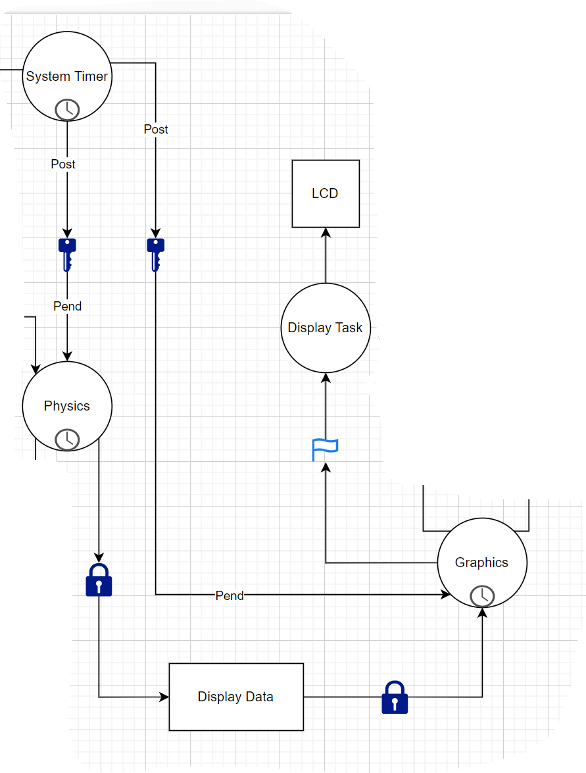

Figure 1: task diagram work focus

My primary goal for this week was to be able to start seeing my data and calculations on the LCD screen. The current appearance of my LCD screen is shown in fig. 2.

Figure 2: Current Graphics

To this goal I first defined all of the initial objects’ parameters. These parameters were primarily the borders of each object. An enumeration was used for each object to allow easy adjustment of variables during testing. I then began adding the physics processing. All of the inputs were written in week 2 so the main work of this week was completing hand examples and ensuring that the calculations within my program matched with the handwritten examples. Currently, the platform is able to move according to the forces applied to it via the slider, and is able to fire a slug. This slug is governed by simple physics equations, including deceleration on the y-axis due to gravity. It is currently detected when the slug strikes any object or the floor of the canyon, though the object graphics do not update at this time. Table 1 is an updated list of the current project status and tasks remaining.

|  |  |  |  |
| --- | --- | --- | --- |
| **Task** | **Time Estimate** | **Actual Time Used** | **Status** |
| Task Diagram | 3 hours | 5 hours | Complete |
| Physics hand examples | 3 hours | 3 hours | Partially complete |
| Write Input Tasks | 5.5 hours | 7.5 hours | Complete |
| Write Physics Tasks | 8 hours | 4.5 hours | Partially complete |
| Write Display Tasks | 8 hours | 4.5 hours | Partially complete |
| Integrate Tasks | 3 hours | ---------- | Not Started |
| Debug Final Code | 5 hours | ---------- | Not Started |

Table 1: Project Progress

**Unit Tests:**

Buttons:

* If button 0 is pressed it triggers an interrupt, which then increments the charge level of the capacitors every 1 second while it is held.
  + pass
* If button 0 is released an interrupt is triggered. This then sets the capacitor energy counter to zero and indicates that a fire operation is required.
  + pass
* If button 1 is pressed while the capacitor energy level is zero, nothing happens.
  + pass
* If button 1 is pressed while the capacitor energy level is greater than zero, the capacitor energy counter is set to zero and it indicates that a shield operation is required.
  + pass
* When button 1 is released, no additional interrupt is generated and is ignored as input.
  + pass

Slider:

* The slider’s input is periodically sampled.
  + pass
* If the slider is touched the variable tracking what level and direction of force is required is set.
  + pass
* If the slider is not being touched, the tracking variable is reset to a no applied force state.
  + pass

Physics

* task runs periodically
  + pass
* calculations maintain a precision of at least 1/100.
  + Pass

Display

* Platform does not move through walls
  + Pass
* Slug size changes with given size parameter
  + Pass
* Slug follows a parabolic flight path according to physics calculations
  + Pass
* Satchels fly at random angles
  + Fail
* Satchels detonate when striking any horizontal surface
  + Fail
* Satchel follow parabolic flight path according to physics calculations
  + Fail
* Button 0 charges capacitor bar
  + Pass
* Button 1 resets capacitor bar while charging
  + Pass

Castle

* Impacts by a slug are accurately tracked
  + Fail
* Impacts are displayed on the LCD
  + Fail

LEDs

* Death due to damage is indicated
  + Fail
* Escape of prisoners is indicated
  + Fail

**Risk Register**

